- Add each person who will be attending, who is not already on your account

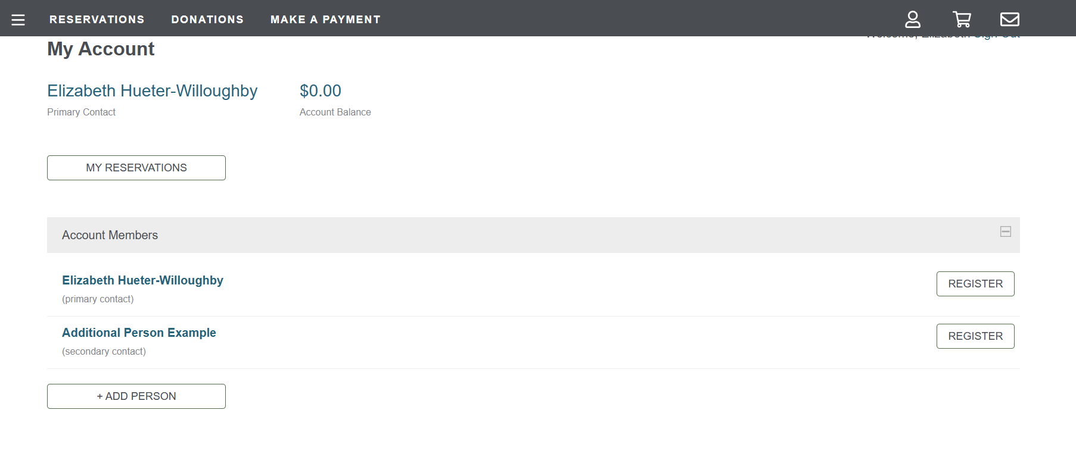

- Click on the Reservation Tab
You will get directed to the page below and select “Explore Sessions”

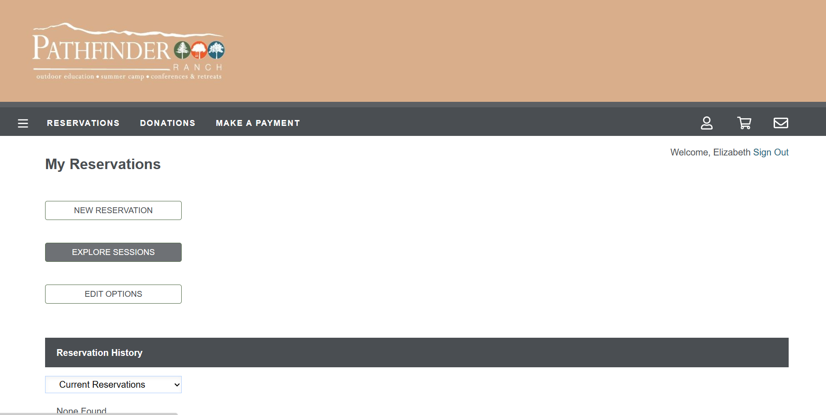

- Scroll down the page to find the session that you want to sign up for.
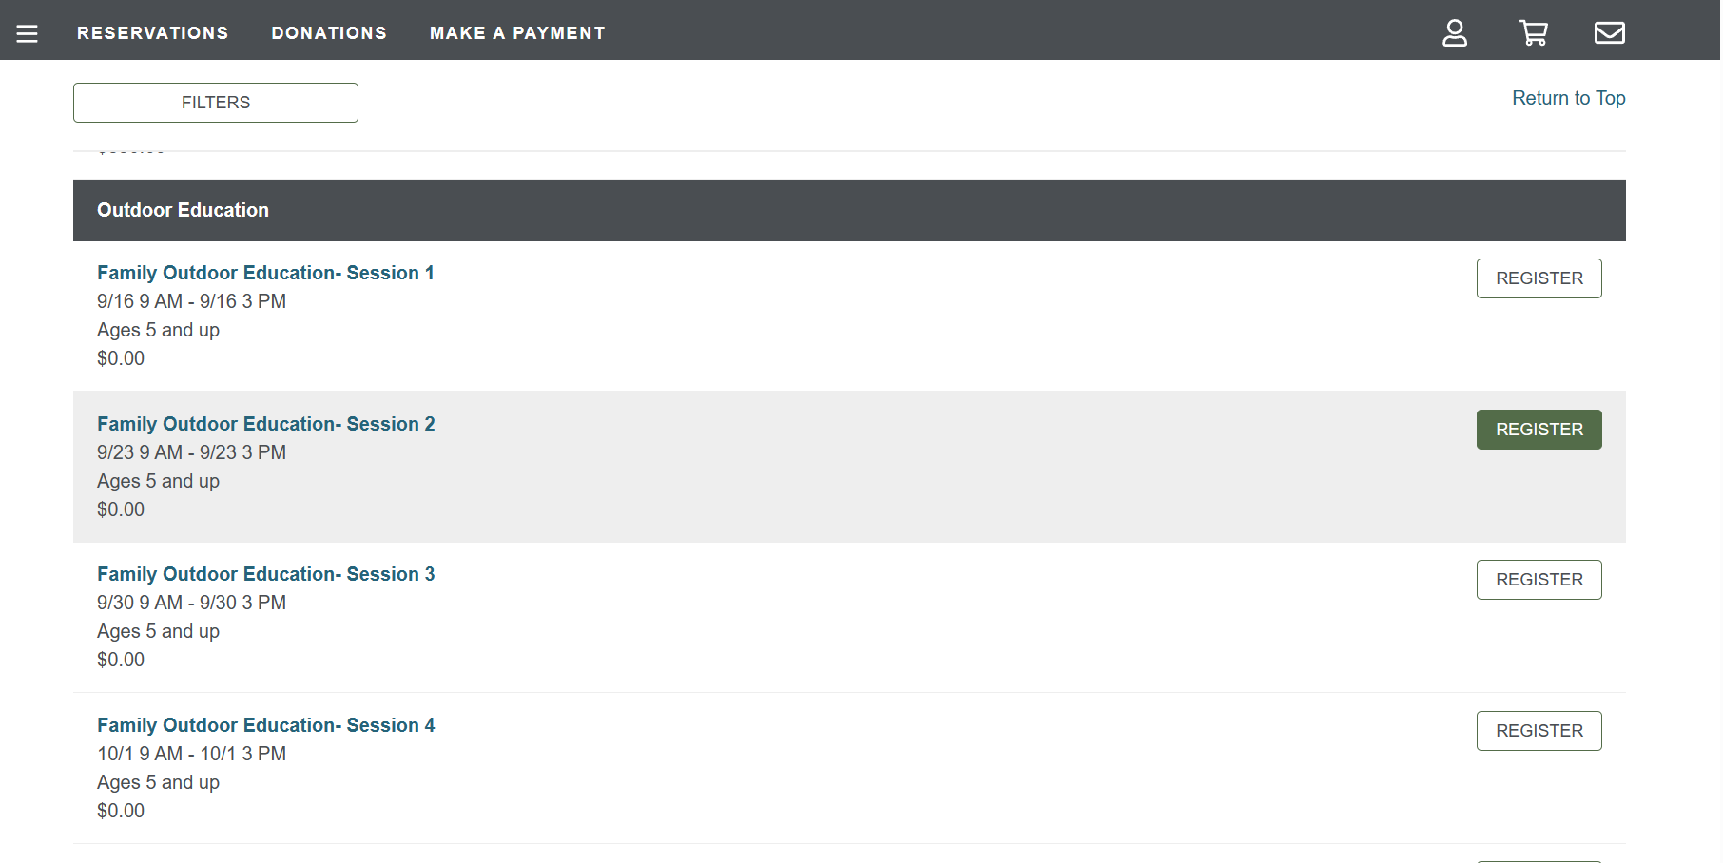

- Complete all of the forms that you will be automatically directed to.

- Once you have filled out the forms, you will be directed to the page below.

Select complete order and you are done.

